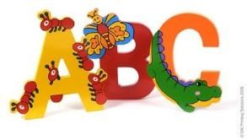
Kindergarten Kickoff!

Wednesday, August 21, 10am-11am Memorial Hall
Join MHL's Children's Room staff for a fun event to help get ready for
Kindergarten! This program is for children entering Kindergarten in September 2019. The event will include sharing a story together, information about going to Kindergarten to help children and
parents, and various activity stations related to learning and sharing. The stations will focus on important steps to literacy such as talking, singing, reading, writing, playing,
self-help, and motor skills. There will be a door prize and free books for the Kindergarteners provided by one of our
sponsors the Michael B. Christensen Community and Family Support Center. and Greater Lawrence Community Action Council. This event is also co-sponsored by the Friends of Memorial
Hall Library. Representatives from the Andover Public Schools and Elementary Schools will also attend to answer questions and share information. Please register online the family name and how many adults and children will attend.

